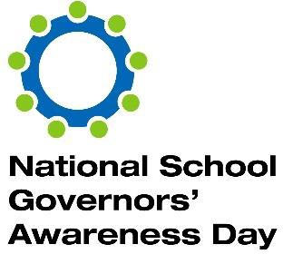

National School Governors’ Awareness Day
The day is all about raising awareness of school governance and celebrating the contribution that governors and trustees make to improving the lives of children and young people.

When 22nd February 2022 (all the twos)

Where Virtual (all online)

What A structured day of events, free to access for all, preceded by a multi- media campaign to promote the event.

How - Three webinars (22.2.22):
- Hot Topics
- The Nine Habits of Trust
- Recruiting Governors
- Workload and Well-being – the role of governance

- Submission of videos – What governance means to me.

- Free e-postcards for Headteachers to send to governors.

- Supported by:
  - Governors for Schools
  - National Coordinators of Governance Services (NCOGS)
  - GovernorHub
  - iGovs

- Promoted through a concerted press relations campaign aimed at national media, educational media, and every governing board in the country.
- Website: https://schoolgovernorsday.co.uk/
- Twitter: @SchoolGovDay #SchoolGovDay

