The Staff Governor – Information for potential applicants

Before applying to become a staff governor, it is strongly recommended that you understand the role of a governor. This information sheet is designed to support your understanding. If you have any questions about the role, please ask before you apply.

The role of school governing bodies
Governing bodies are the strategic leaders of our schools and have a vital role to play in making sure every child gets the best possible education. This is reflected in the law, which states that the purpose of (maintained) school governing bodies is to ‘conduct the school with a view to promoting high standards of educational achievement at the school’

The principles of school governance are the same in every school no matter whether the school is an academy, free school or maintained school. They are all state funded schools.

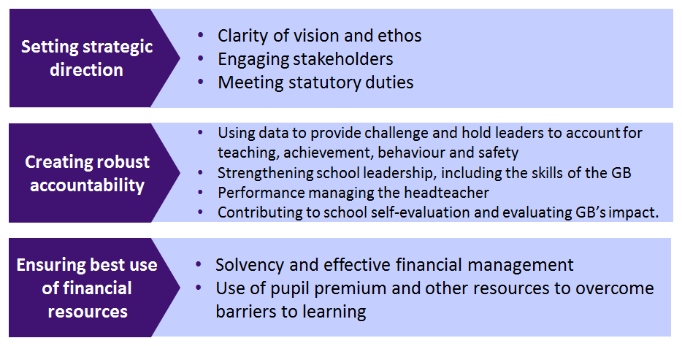
All governing bodies should operate as non-executive boards, focussing on three core strategic functions.

A governing body play a strategic role not an operational one. The headteacher is responsible for the day to day management of the school (operational) and the headteacher and staff are responsible for implementing plans and policies established by the governing body. Understanding what this means is probably the most important thing to learn about being a governor.

In exercising their strategic functions the governing body shall:
• act with integrity, objectivity and honesty and in the best interests of the school; and
• be open about the decisions they make and the actions they take and in particular shall be prepared to explain their decisions and actions to interested parties.

Much of the work of a governing body is conducted in meetings. Almost all of the powers and responsibilities of governing bodies are held collectively, and this means that the governing body has to meet to make its decisions.

Due to the vast array of duties that governing bodies have, it is most likely that the governing body will use its powers of delegation to distribute its workload to ensure matters are dealt with appropriately. It may choose to delegate duties to a committee or an individual.

Nearly all governing bodies will have committees to help distribute the governing body's duties among those members who have skills or interests in a particular area of school life, for example, finance, staffing or curriculum. Governing body committees can discuss delegated duties in further detail and report back to the full governing body about their findings, recommendations, or decisions.

A governing body acts as a single person with an identity separate from its members. Responsibility for the actions and decisions of the governing body lies with the whole governing body rather than individual members. This is known as corporate responsibility.

Governors must never carry out a duty in the name of the governing body without the consent of the governing body. Governing bodies must act as a group/corporate body. Individual governors have no power outside the governing body and cannot act on behalf of the governing body unless authorised to do so or, in special cases, where emergency action is needed (chair of governors).

The role of a school governor
This is an edited extract from Welcome to Governance 6th Edition, published by the National Governors’ Association (NGA).

What does a governor do?
Role of a school governor is to contribute to the work of the governing body in ensuring high standards of achievement for all children and young people in the school.

Expectations of the role
As a governor you are expected to:
• Have a real interest in education and developing positive outcomes for all children
• Get to know the school: its needs, strengths and areas for development
• Prepare for, and attend meetings (full governing body, committees and working groups)
• Actively contribute as a member of a team
• Speak, act and vote in the best interests of the school
• Use your personal and professional skills to support the school
• Respect all governing body decisions and to support them in public
• Act within the framework of the policies of the governing body and legal requirements
- Observe and follow the governing body’s code of conduct and confidentiality requirements
• Commit to training and development opportunities

Activities: As part of the governing body, a governor is expected to

1 Contribute to the strategic discussions at governing body meetings which determine:
- the vision and ethos of the school;
- clear and ambitious strategic priorities and targets for the school;
- that all children, including those with special educational needs, have access to a broad and balanced curriculum;
- the school’s budget, including the expenditure of the pupil premium allocation;
- the school’s staffing structure and key staffing policies;
- the principles to be used by school leaders to set other school policies.

2 Hold the senior leaders to account by monitoring the school’s performance; this includes:
- agreeing the outcomes from the school’s self-evaluation and ensuring they are used to inform the priorities in the school development plan;
- considering all relevant data and feedback provided on request by school leaders and external sources on all aspects of school performance;
- asking challenging questions of school leaders;
- ensuring senior leaders have arranged for the required audits to be carried out and receiving the results of those audits;
- ensuring senior leaders have developed the required policies and procedures and the school is operating effectively according to those policies;
- acting as a link governor on a specific issue, making relevant enquiries of the relevant staff, and reporting to the governing body on the progress on the relevant school priority; and
- listening to and reporting to the school’s stakeholders: pupils, parents, staff, and the wider community, including local employers.

3 Ensure the school staff have the resources and support they require to do their jobs well, including the necessary expertise on business management, external advice where necessary, effective appraisal and CPD (Continuing Professional Development), and suitable premises, and that the way in which those resources are used has impact.

The role of governor is largely a thinking and questioning role, not a doing role. This means that it is a strategic role, not an operational role in school.

A governor does NOT:
- Write school policies;
- Undertake audits of any sort – whether financial or health & safety - even if the governor has the relevant professional experience;
- Spend much time with the pupils of the school – if you want to work directly with children, there are many other voluntary valuable roles within the school;
- Fundraise – this is the role of the PTA – the governing body should consider income streams and the potential for income generation, but not carry out fundraising tasks;
- Undertake classroom observations to make judgements on the quality of teaching – the governing body monitors the quality of teaching in the school by requiring data from the senior staff and from external sources;
- Do the job of the school staff – if there is not enough capacity within the paid staff team to carry out the necessary tasks, the governing body need to consider and rectify this.

As you become more experienced as a governor, there are other roles you could volunteer for which would increase your degree of involvement and level of responsibility (e.g as a chair of a committee).

Time commitment
Under usual circumstances, you should expect to spend between 10 and 20 days a year on your governing responsibilities; the top end of this commitment, which equates to about half a day per week in term time, is most relevant to the chair and others with key roles, such as chairs of committees. Initially, we would expect your commitment to be nearer 10 days a year. However, there may be periods when the time commitment may increase, for example when recruiting a headteacher. Some longstanding governors may tell you that they spend far more time than this on school business; however, it is fairly common for governors to undertake additional volunteering roles over and above governance.

Your main task is to attend meetings and contribute to the work of the governing body. Meetings of the full governing body normally take place once or twice a term and each committee normally meets once a term but may meet more frequently depending on its remit and the school’s circumstances. Each school is different in respect of their schedule of meetings. You should clarify with your governing body the time commitment required.

Under Section 50 of the Employment Rights Act 1996, if you are employed, then you are entitled to ‘reasonable time off’ to undertake public duties; this includes school governance. ‘Reasonable time off’ is not defined in law, and you will need to negotiate with your employer how much time you will be allowed.

Expenses
Governors may receive out of pocket expenses incurred as a result of fulfilling their role as governor, your school’s governing body should have such an expenses policy. Payments can cover incidental expenses, such as travel and childcare, but not loss of earnings.

Training
All governors are expected to undertake training to support them in their role. Each school has a budget which allows for this. Governors do not fund training from their own pocket. Your school may buy training and support for governors from a specific service provider, and they will provide detail of this to you if your join the governing body.

All new governors are strongly recommended to undertake face to face induction training within the first 6 months of becoming a governor. This will give you the opportunity to meet other new governors and clarify the role and responsibilities in more detail.

Details of current training events locally in Hillingdon can be found here: http://www.governor.support/events/. An expectation of undertaking the governor role is committing to attending to training and using what you have learned to support the work of the governing body.

Other sources of information

Websites
Department for Education https://www.gov.uk/government/organisations/department-for-education
School Governors One Stop Shop (SGOSS) https://www.sgoss.org.uk/
Governor Support Service (Hillingdon) www.governor.support
National Governors Association (NGA) http://www.nga.org.uk/
Inspiring Governors Alliance http://www.inspiringgovernors.org/

YouTube clips on the governor role
https://www.youtube.com/watch?v=Hnm6BV5ft-8
https://www.youtube.com/watch?v=GH8u5eOFjIE
https://www.youtube.com/user/sgossorg

The ‘Seven Principles of Public Life’
It is vital that from the offset as a potential new governor that you understand that all governors are public volunteers and as such are subject to the same Nolan Committee rules on public life as Councillors and MPs.

The Nolan committee rules are known as the ‘Seven Principles of Public Life’. The principles are given below.

Selflessness
Holders of public office should take decisions solely in terms of the public interest. They should not do so in order to gain financial or other material benefits for themselves, their family or their friends.

Integrity
Holders of public office should not place themselves under any financial or other obligation to outside individuals or organisations that might influence them in the performance of their official duties.

Objectivity
In carrying out public business, including making public appointments, awarding contracts or recommending individuals for rewards and benefits, holders of public office should make choices on merit.

Accountability
Holders of public office are accountable for their decisions and actions to the public and must submit themselves to whatever scrutiny is appropriate to their office.

Openness
Holders of public office should be as open as possible about all the decisions and actions that they take. They should give reasons for their decisions and restrict information only when the wider public interest clearly demands this.

Honesty
Holders of public office have to declare any public interests relating to their public duties and to take steps to resolve any conflicts arising in a way that protects the public interest.

Leadership
Holders of public office should promote and support these principles by leadership and example.

Contact
Thank you for taking the time to read through this information. If you have any questions about the role, please contact:

Name and position
Email address

