Governor Support Service
0

Unit 1,Britannia Court, The Green, West Drayton, UB7 7PN
01895 717321, office@governor.support, www.governor.support

Staff Governor Elections

This guidance applies to all maintained community, community special, maintained nursery and voluntary controlled schools in the London Borough of Hillingdon.

2019

Contents

Page
2
3
9
9
10
Introduction and background
Conducting a Staff Governor Election Frequently Asked Questions
List of resources available with this guidance
Copy of resources

About this guide
This guidance has been put together by the Governor Support Service in Hillingdon. It uses edited information from the Department for Education and the Governor Support Service (GSS). It is designed to guide Headteachers, governors and clerks through the regulations and process of staff governor
elections in maintained community, community special, maintained nursery and voluntary controlled schools in the London Borough of Hillingdon.

About us
The GSS is an independent service offering governor training, advice, guidance and support to all Hillingdon Schools. With over 20 years’ combined experience working within local authorities in Governor Support roles, we are able to offer local and legislative advice, support and training to school governors and clerks.

The support we provide aims to enables governors to focus on their key roles and responsibilities – therefore assisting you to enable your school to deliver a good quality education.

Schools that subscribe to our service level agreement can access guidance on their statutory and non-statutory duties at no additional cost. All other schools can purchase our support services and training on a pay as you go basis.

Contact us

Governor Support Service | Tel: Mobile: Email: Website: | 01895 717321  07881 238127  office@governor.support www.governor.support
Unit 1, Britannia Court
The Green
West Drayton
UB7 7PN

Follow us

@govsandclerks https://www.facebook.com/governorsupport

Introduction and background

Staff governors
The definition of a staff governor is a person who is paid to work at the school, and who is in paid employment at the school at the time of election. Voluntary workers at the school are not eligible for staff governorship.

Employees of the school who are on long term continuous contracts may stand as staff governors and vote in elections.

Persons contravening the circumstances under which any person is disqualified from holding or continuing in office are set out in the nomination form. Candidates for election must sign to declare that they do not fall into any disqualification category.

Upon ceasing to work at the school, a staff governor of a school will be disqualified from continuing to serve as a staff governor at the school.

It is not possible to make a temporary appointment in the event of other staff governors being on extended sick leave or maternity leave. The governing board could agree to another person attending (perhaps as an associate member) but s/he would not be able to vote on any issue requiring a formal vote.

Staff governors will be elected to office for a period of four years, unless the school’s Instrument of Government (under the School Governance (Constitution) (England) Regulations 2012) specifies a shorter term of office.

What legislation determines that a governing board must have staff governors?
- The Education Act 2002
- The School Governance (Constitution) Regulations 2012
- The School Governance (Constitution and Federations) (England)(Amendment) Regulations 2017

What is their role?
Once elected, a staff governor takes on the role of school governor, public volunteer. All governors are equal, no category of governor is any more important or influential than any other. Staff governors are representative of and exercise a strategic employee voice on a governing board. They cannot be mandated by anyone to take any particular course of action or decision.

Teachers and members of the support staff of the school have knowledge, experience and views to bring to the governing board and can help to increase all governors’ understanding of the school.

As part of the governing board, which has corporate responsibility, governors are the strategic leaders of our schools and have a vital role to play in making sure every child gets the best possible education. All governors must ensure that the governing board has a strong focus on their three core strategic functions:
- Ensuring clarity of vision, ethos and strategic direction;
- Holding the headteacher to account for the educational performance of the school and its pupils; and
- Overseeing the financial performance of the school and making sure its money is well spent.

These functions are reflected in the regulations for maintained schools which came into force in September 2013 and in the criteria Ofsted inspectors use to judge the effectiveness of a school’s governing board.

All members of a governing board have equal status in the responsibilities they share and with few exceptions, a staff governor is, in every sense, a full governor with the same rights to participate and contribute to shared decisions as any other. The exceptions are:

- Staff employed at the school cannot hold the office of Chairman or Vice Chairman of the governing board, but they may chair committees.
- Staff employed at the school must withdraw and not take part in discussions relating to the appraisal or pay of any school employee (all governors need to withdraw if they have a pecuniary or other interest in any item under consideration by the governing board).
- They cannot take part in the Headteacher’s performance management.
- The Headteacher cannot be a member of any staff dismissal or staff dismissal appeal committee or the pupil discipline committee which the governing board chooses to establish.
- School employees cannot be LA governors in their own schools.

All governors have a right to take part in discussion on all items, put items on the agenda and so on. The only exceptions to this general rule the individual governor has some other direct personal interest in the matter, for example a financial or employment interest which is greater than that of the other governors.

Staff governors need to be aware that they share a collective responsibility with other governors and can never act alone unless they have the express approval of the full governing board. They are not there to override existing school systems, for example, relating to individual parental or staffing complaints. They are a two-way channel of communication, feeding views of staff into governing board meetings, and then, if required, reporting back on decisions reached without breaking the confidentiality of the meetings.

Any governor would be breaching the confidence of the governing board if they reported how individuals voted, comments made by individuals, or individual discussions.

When reporting on decisions taken by the governing board all governors should use ‘we’ and not ‘they’ as they are part of the decision-making group. Even if a governor voted against the final decision they must support the corporate decision-making process, and take ownership of the outcome.

Conducting a Staff Governor Election

In the London Borough of Hillingdon, responsibility for conducting the elections is delegated to the Headteacher who acts as returning officer in accordance with the LA’s procedures in this guidance document.

The Headteacher may wish to conduct the election process with assistance from the Clerk to Governors with agreement from the governing board.

There is only one place for a staff governor and one place for the Headteacher as a governor under the School Governance (Constitution) Regulations 2012.

All teaching and support (non-teaching) staff are represented in this staff governor category. The staff governor is elected into office by all members of school staff (teaching and support), who are paid to work at the school.

The Timeline and Process
Please note that all days are calculated on school days.

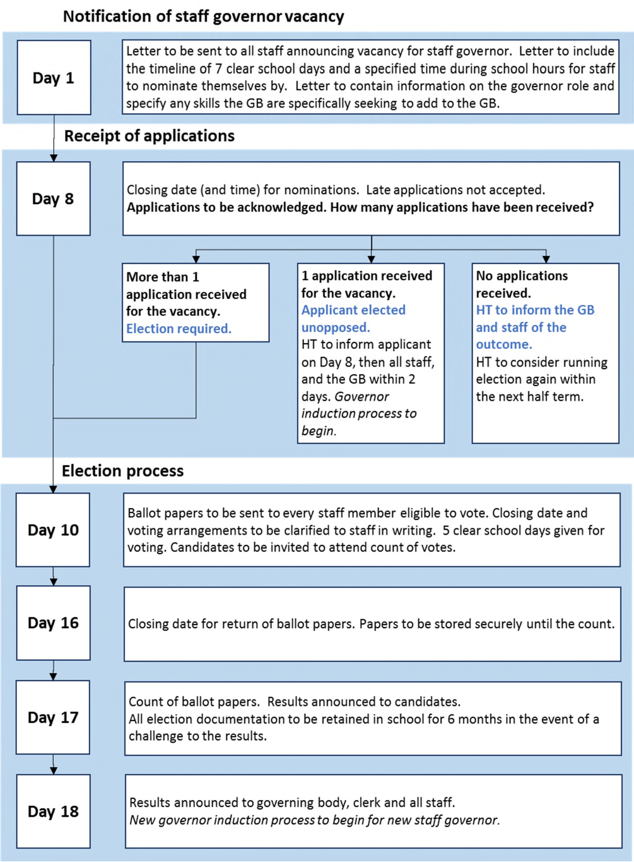
If the full timeline for an election cannot be carried out, it would be advisable to begin the process when there is a clear 18 school day period for the process to take place. The process can be deferred to the next term or half term.

Notifying Staff of a Staff Governor Vacancy
A Staff Governor Vacancy Notice (template available) should be sent to all members of staff paid the work at the school by the Headteacher. This may be accomplished:
- by internal post
- by external post
- electronically (where available)

Every eligible member of staff at the school must be given the opportunity to self-nominate for an election, unless disqualified from holding office under the School Governance Regulations. Nominees must sign a declaration to confirm that they do not meet the disqualification criteria. The declaration forms part of their nomination form and this information is given further on in this guidance.

The Staff Governor Vacancy Notice must:
- invite nominations to be submitted to the school on an appropriate nomination form
- give information on the role of the staff governor and where further information may be obtained
- explain the circumstances surrounding when an election will or will not take place
- specify a deadline (date and time) for the return of nomination forms giving a minimum of seven clear school days for the return
- specify from what date the staff governorship became or will become available.
- be signed by the Headteacher.

Nominations
All candidates nominating themselves for the staff governor post must be employed to work at the school on the closing date for the receipt of nominations.

The nomination form must invite candidates to submit details of their skills and attributes and a personal statement about why they wish to volunteer as a school governor. These sections must be collated for circulation to all other staff with the ballot papers. No personal contact data should be circulated.

The character limit for the personal statement is set at 1400 characters maximum, with a separate section for a bullet point list of personal and/or professional skills. All candidates must use the same application form provided by the school (template available). Candidates may complete the form in legible handwriting. Alternatively, the school should make this form available electronically and all candidates must be given the opportunity to use the electronic version. This could be posted on the schools website for ease of access.

Circumstances under which no ballot is required
If there is only one nomination, then the nominee is deemed elected unopposed.

If no nominations are received, no ballot can take place. In this instance, this should communicated to staff and a notice posted on any staff notice boards, informing them of a nil result and any person with an interest in filling the vacancy to contact the Headteacher as soon as practicable in order for an election to take place.

Neither the Headteacher or the governing board have the power to appoint a staff governor.

When a staff governor is elected or elected unopposed, this must be reported at the next governing board meeting for it to be recorded in the full governing board minutes.

Circumstances under which a ballot is required
If there is more than one nomination for the staff governor vacancy it will be necessary to hold a secret ballot.

The Ballot
The ballot paper must be sent to all members of staff who are paid to work at the school. Information about the voting procedure should be included in the letter which accompanies the ballot paper, together with notice of the date and time by which the ballot papers must be returned - at least five school days must be allowed.

All members of staff who are paid to work at the school are entitled to one vote. This includes the Headteacher.

If a ballot paper is inadvertently spoilt, or lost, a duplicate may be issued by the Headteacher.

In order that the ballot is secret, and also that it is possible to be certain that all votes received are from staff eligible to vote, it is recommended that a double envelope system be used. Staff should be asked to place the ballot paper in an (inner) unmarked envelope and to return it to the school in an outer envelope, which they should sign. This guidance provides an example of the outer envelope information/self-adhesive label (template available). The envelopes should all be placed in a ballot box ideally in the staff room.

Voting envelopes may be returned to the school by:
- hand delivery
- by external post
- by internal post.

No arrangements may be made for proxy voting.

A proper two-stage system of recording votes cast, and opening ballot papers must be used. On receipt of the envelopes the returning officer should check the name on the outer envelope for eligibility to vote and note the return of the ballot paper. Once eligibility to vote has been established, the outer envelope may be discarded and the inner one placed in the ballot box for counting at the appointed time. [If the voter chooses not to maintain confidentiality in this way, as long as it is clearly demonstrated on the ballot paper or a single envelope that the person is entitled to vote, the ballot paper is to be counted as valid].

Once the appointed time for the close of the ballot has been reached, no further votes can be accepted.

After the ballot has closed, the Headteacher should open and count the ballot papers in the presence of at least two witnesses. It is recommended that the nominees should be invited to attend the count, although, of course, the process should not be delayed if any of the nominees are unable to be present. The Headteacher should determine whether a spoiled voting paper is valid.

The outcome of the ballot is determined by a simple majority vote system.

In the event of an equal number of votes being cast there should be a recount. If this does not produce a clear result the Headteacher, should, in the presence of the witnesses, draw lots.

Immediately after the finalisation of the election, the Headteacher should contact the nominees (unless they were present at the count) to notify them of the result. This can be done verbally and then confirmed in writing, giving a clear start date for the term of office and when that term will expire.

The ballot papers should be retained securely for six months in case the election result is challenged. The number of ballot papers issued, and the number returned, at each election, must be recorded. This can be done on an Election Result Record Sheet (template available), which should accompany the retained ballot papers. When the ballot papers are discarded, the clerk should retain the election result record sheet

Election Results
The outcome of any staff governor election must be notified to all staff as soon as it is practicable after the election and after all nominees have been notified of the result. This can be done on an Election Result Notice (template available) and reported in any staff briefings/newsletters, etc.

The Headteacher must report the result of the election to the chair of the governing board and clerk to governors within 2 days.

The new staff governor must be informed about induction training and procedures, and visiting the school as a governor for the first time.

It is recommended that the clerk to governors provides the newly elected staff governor with:
- a letter welcoming them to the governing board, stating their term of office and giving details of any DBS check that they may be requested to undergo
- details of induction training and visiting the school as a governor for the first time.
- a list of dates, times and venues of all forthcoming governing board meetings
- a copy of the instrument of government (constitution of the governing board)
- membership list of the full governing board with contact details for the clerk and chairman
- a copy of minutes from the last full governing board meeting
- a bespoke welcome pack for new governors from the school (advice available from Governor Support Service)
- any other information the governing board considers necessary.

Results of the election should be officially reported at the next governing board meeting and recorded in the minutes. The chairman of governing board should officially welcome the new staff governor when attending their first full governing board meeting.
All new governors and their contact details must be supplied to the Governor Support Service. Email these details to office@governor.support.

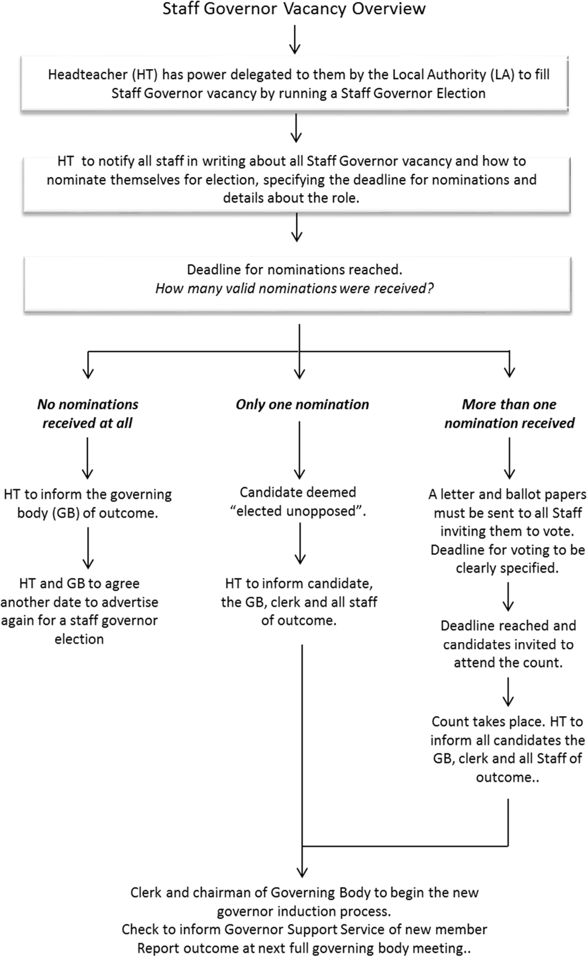

Frequently Asked Questions

What happens if a staff governor leaves the school, can they continue their term of office?
When a staff governor leaves the school, their term of office automatically ceases on the last day of their employment, unless they have tendered their resignation earlier.

Can a staff governor election take place in advance of the vacancy becoming available (i.e. a term of office is due to expire shortly)?
Yes, but all documentation to staff must be clear that the term of office is effective from a specific date when the vacancy exists.

What happens if someone submits something inappropriate to the tone of the election in their personal statement?
Political and religious views must not feature in any personal statement. The Headteacher should speak to the individual about why their statement is considered inappropriate for distribution as it stands, and the candidate should be given an opportunity to either withdraw or rewrite the statement as soon as possible. Advice should also be sought from the Governor Support Service as soon as possible.

Can staff governor candidates canvass other staff to vote for them?
Yes, they can, this opportunity is afforded to all candidates and they may or may not choose not to do so. Candidates must not canvass for votes during working time or use any child or member of staff to support them in any part of this process. If any inappropriate behaviour is used and reported, then the Headteacher should speak to the individual(s) with their concerns.

What if there is a query about staff governor elections that is not covered by this guidance?
Please call the Governor Support Service for assistance as soon as possible. Contact details are given on the front page of this guidance.

List of resources available with this guidance

We have included with this guidance the templates you will need. Schools can tailor them with schools logos and details etc.

- Model letter to staff about governor vacancy
- Staff Governors – Info for Applicants
- Staff Governor Nomination form 2016
- Staff Governor Election Procedure Letter from Headteacher
- Staff Governor Ballot Paper
- Voting Labels for Envelopes
- Staff Governor Election Record Sheet
- Staff Governor Election Result Notice

Insert School Name, Address and Logo

Date

Dear Colleagues
Can you help shape the future of our school?

We need a member of staff employed at the school to make a difference in our school’s community by volunteering to become a staff governor.

Your voice as a member of staff is very important to our school and it is vital that the governing board has representation by our staff among its membership.

Information about the role
Once elected or appointed for a term of four years, a staff governor takes on the role of a school governor, a public volunteer. All governors are equal, no category of governor is any more important or influential than any other. Staff governors exercise a strategic employee voice on the governing board.

I have included a more detailed information on the role of governors with this letter. Please read this as it is important to understand the role, expectations and commitment before applying.
We are seeking a member of staff who has a real willingness to help, who can listen carefully, read important documents, ask questions, attend training and be able to actively contribute at meetings.

If you can spare approximately ten hours or more a month then please consider nominating yourself for this interesting voluntary role.

The governing board is particularly seeking applicants with the following skills ….(insert skills)

What can you offer as a staff governor?
- Enthusiasm, time and commitment.
- Your local knowledge will be valuable: you will have a feel for what is important to people.
- Any professional or other skills you may have will be very helpful.
- An openness to learning and change, and wanting to make a difference.
- Governors also provide objectivity in debate and decision-making and can add further and different perspectives to school matters.

What are the benefits?
- Being a school governor is a privilege – you are a small but very important part in an educational system with a very long history.
- The knowledge that you have played a part in improving local children's education and supported the school's staff.
- A chance to develop new skills, to practice and strengthen existing ones, such as chairing a committee meeting, researching or leading on a key school issue.
- The opportunity to work as part of a team to make a real difference in the community.
- The opportunity to meet new people from all walks of life whom you probably would not have otherwise encountered.

- Knowing that the decisions you collectively make will have a huge impact on children’s lives.
- You develop as a person and may even find that your experiences as a governor influence future career and life choices.

If you are interested in volunteering, here’s what you should do …
- Please check that you are eligible to stand as a staff governor. There are some criteria which can disqualify you from serving as any type of governor. This list is given in the nomination form. If you are applying, then you must confirm that you are not disqualified by those criteria.

- Please nominate yourself by completing the attached nomination form. If you wish to have an electronic copy of the form it can be [downloaded from our website or] emailed to you. Please contact [NAME] on [NUMBER], [EMAIL] to arrange this.

- Please ensure that your completed nomination from is returned to the school by [TIME] on [DATE]. There is a Nomination Box in the school Reception area for the collection of nominations.

What happens after the nomination deadline has passed?
Any nominations received after the deadline will not be accepted.

If the school receives more nominations than the one vacancy, then we will hold an election and all staff will be asked to take part in a secret ballot to vote for the candidate they feel would be most suitable as a staff governor. The information you supply as part of your nomination will be circulated to staff to help them decide who to vote for. Your personal contact details will not be distributed. This is for governing board purposes only.

If the school receives one nomination for the one vacancy, then that nominee is deemed to be ‘elected unopposed’ and becomes a staff governor without the need for an election.

If no staff nominate themselves by the deadline given above, then the vacancy is held open until a suitable nominee comes forward for election. The governing board cannot appoint staff to the staff governor category.

If an election needs to take place then I will inform all nominees personally, and all staff in writing, providing the details of how to vote and the deadline for doing so.

If there are any questions or you need further information, please let me know as soon as possible.

Yours faithfully

Xxxxx Headteacher

Attachments
- Staff Governor Nomination Form
- Information on the role of governors

Governor Support Service Advice and Guidance Document

The Staff Governor – Information for potential applicants

Before applying to become a staff governor, it is strongly recommended that you understand the role of a governor. This information sheet is designed to support your understanding. If you have any questions about the role, please ask before you apply.

The role of school governing boards
Governing boards are the strategic leaders of our schools and have a vital role to play in making sure every child gets the best possible education. This is reflected in the law, which states that the purpose of (maintained) school governing boards is to ‘conduct the school with a view to promoting high standards of educational achievement at the school’

The principles of school governance are the same in every school no matter whether the school is an academy, free school or maintained school. They are all state funded schools.

All governing boards should operate as non-executive boards, focusing on three core strategic functions.

Governing boards play a strategic role not an operational one. The headteacher is responsible for the day to day management of the school (operational) and the headteacher and staff are responsible for implementing plans and policies established by the governing board. Understanding what this means is probably the most important thing to learn about being a governor.

In exercising their strategic functions, the governing board shall:
- act with integrity, objectivity and honesty and in the best interests of the school; and
- be open about the decisions they make and the actions they take and in particular shall be prepared to explain their decisions and actions to interested parties.

Much of the work of a governing board is conducted in meetings. Almost all of the powers and responsibilities of governing boards are held collectively, and this means that the governing board has to meet to make its decisions.

Due to the vast array of duties that governing boards have, it is most likely that the governing board will use its powers of delegation to distribute its workload to ensure matters are dealt with appropriately. It may choose to delegate duties to a committee or an individual.

Nearly all governing boards will have committees to help distribute the governing board's duties among those members who have skills or interests in a particular area of school life, for example, finance, staffing or curriculum. Governing board committees can discuss delegated duties in further detail and report back to the full governing board about their findings, recommendations, or decisions.

A governing board acts as a single person with an identity separate from its members. Responsibility for the actions and decisions of the governing board lies with the whole governing board rather than individual members. This is known as corporate responsibility.

Governors must never carry out a duty in the name of the governing board without the consent of the governing board. Governing boards must act as a group/corporate board. Individual governors have no power outside the governing board and cannot act on behalf of the governing board unless authorised to do so or, in special cases, where emergency action is needed (chair of governors).

The role of a school governor
This is an edited extract from Welcome to Governance 6th Edition, published by the National Governance Association (NGA).

What does a governor do?
Role of a school governor is to contribute to the work of the governing board in ensuring high standards of achievement for all children and young people in the school.

Expectations of the role
As a governor you are expected to:
- Have a real interest in education and developing positive outcomes for all children
- Get to know the school: its needs, strengths and areas for development
- Prepare for, and attend meetings (full governing board, committees and working groups)
- Actively contribute as a member of a team
- Speak, act and vote in the best interests of the school
- Use your personal and professional skills to support the school
- Respect all governing board decisions and to support them in public
- Act within the framework of the policies of the governing board and legal requirements
- Observe and follow the governing board’s code of conduct and confidentiality requirements
- Commit to training and development opportunities

Activities: As part of the governing board, a governor is expected to

- Contribute to the strategic discussions at governing board meetings which determine:
  - the vision and ethos of the school;
  - clear and ambitious strategic priorities and targets for the school;
  - that all children, including those with special educational needs, have access to a broad and balanced curriculum;
  - the school’s budget, including the expenditure of the pupil premium allocation;
  - the school’s staffing structure and key staffing policies;
  - the principles to be used by school leaders to set other school policies.

Hold the senior leaders to account by monitoring the school’s performance; this includes:
  - agreeing the outcomes from the school’s self-evaluation and ensuring they are used to inform the priorities in the school development plan;
  - considering all relevant data and feedback provided on request by school leaders and external sources on all aspects of school performance;
  - asking challenging questions of school leaders;

  - ensuring senior leaders have arranged for the required audits to be carried out and receiving the results of those audits;
  - ensuring senior leaders have developed the required policies and procedures and the school is operating effectively according to those policies;
  - acting as a link governor on a specific issue, making relevant enquiries of the relevant staff, and reporting to the governing board on the progress on the relevant school priority; and
  - listening to and reporting to the school’s stakeholders: pupils, parents, staff, and the wider community, including local employers.

- Ensure the school staff have the resources and support they require to do their jobs well, including the necessary expertise on business management, external advice where necessary, effective appraisal and CPD (Continuing Professional Development), and suitable premises, and that the way in which those resources are used has impact.

The role of governor is largely a thinking and questioning role, not a doing role. This means that it is a strategic role, not an operational role in school.

A governor does NOT:
- Write school policies;
- Undertake audits of any sort – whether financial or health & safety - even if the governor has the relevant professional experience;
- Spend much time with the pupils of the school – if you want to work directly with children, there are many other voluntary valuable roles within the school;
- Fundraise – this is the role of the PTA – the governing board should consider income streams and the potential for income generation, but not carry out fundraising tasks;
- Undertake classroom observations to make judgements on the quality of teaching – the governing board monitors the quality of teaching in the school by requiring data from the senior staff and from external sources;
- Do the job of the school staff – if there is not enough capacity within the paid staff team to carry out the necessary tasks, the governing board need to consider and rectify this.

As you become more experienced as a governor, there are other roles you could volunteer for which would increase your degree of involvement and level of responsibility (e.g. as a chair of a committee).

Time commitment
Under usual circumstances, you should expect to spend between 10 and 20 days a year on your governing responsibilities; the top end of this commitment, which equates to about half a day per week in term time, is most relevant to the chair and others with key roles, such as chairs of committees. Initially, we would expect your commitment to be nearer 10 days a year. However, there may be periods when the time commitment may increase, for example when recruiting a headteacher. Some longstanding governors may tell you that they spend far more time than this on school business; however, it is fairly common for governors to undertake additional volunteering roles over and above governance.

Your main task is to attend meetings and contribute to the work of the governing board. Meetings of the full governing board normally take place once or twice a term and each committee normally meets once a term but may meet more frequently depending on its remit and the school’s circumstances. Each school is different in respect of their schedule of meetings. You should clarify with your governing board the time commitment required.

Under Section 50 of the Employment Rights Act 1996, if you are employed, then you are entitled to ‘reasonable time off’ to undertake public duties; this includes school governance. ‘Reasonable time off’ is not defined in law, and you will need to negotiate with your employer how much time you will be allowed.

Expenses
Governors may receive out of pocket expenses incurred as a result of fulfilling their role as governor, your school’s governing board should have such an expenses policy. Payments can cover incidental expenses, such as travel and childcare, but not loss of earnings.

Training
All governors are expected to undertake training to support them in their role. Each school has a budget which allows for this. Governors do not fund training from their own pocket. Your school may buy training and support for governors from a specific service provider, and they will provide detail of this to you if your join the governing board.

All new governors are strongly recommended to undertake face to face induction training within the first 6 months of becoming a governor. This will give you the opportunity to meet other new governors and clarify the role and responsibilities in more detail.

Details of current training events locally in Hillingdon can be found here: http://www.governor.support/events/. An expectation of undertaking the governor role is committing to attending to training and using what you have learned to support the work of the governing board.

Other sources of information

Websites
Department for Education https://www.gov.uk/government/organisations/department-for-education
Governors for Schools www.governorsforschools.org.uk
Governor Support Service (Hillingdon) www.governor.support
National Governance Association (NGA) http://www.nga.org.uk/
Inspiring Governors Alliance http://www.inspiringgovernors.org/

YouTube clips on the governor role https://www.youtube.com/watch?v=Hnm6BV5ft-8 https://www.youtube.com/watch?v=GH8u5eOFjIE https://www.youtube.com/user/sgossorg

The ‘Seven Principles of Public Life’
It is vital that from the offset as a potential new governor that you understand that all governors are public volunteers and as such are subject to the same Nolan Committee rules on public life as Councillors and MPs.

The Nolan committee rules are known as the ‘Seven Principles of Public Life’. The principles are given below.

Selflessness
Holders of public office should take decisions solely in terms of the public interest. They should not do so in order to gain financial or other material benefits for themselves, their family or their friends.

Integrity
Holders of public office should not place themselves under any financial or other obligation to outside individuals or organisations that might influence them in the performance of their official duties.

Objectivity
In carrying out public business, including making public appointments, awarding contracts or recommending individuals for rewards and benefits, holders of public office should make choices on merit.

Accountability
Holders of public office are accountable for their decisions and actions to the public and must submit themselves to whatever scrutiny is appropriate to their office.

Openness
Holders of public office should be as open as possible about all the decisions and actions that they take. They should give reasons for their decisions and restrict information only when the wider public interest clearly demands this.

Honesty
Holders of public office have to declare any public interests relating to their public duties and to take steps to resolve any conflicts arising in a way that protects the public interest.

Leadership
Holders of public office should promote and support these principles by leadership and example.

Contact
Thank you for taking the time to read through this information. If you have any questions about the role, please contact:

Name and position
Email address

SCHOOL NAME, ADDRESS AND LOGO

Staff Governor Nomination Form
Personal details

Title Name Surname

Gender Please tick ✓ the appropriate response Female Male

Job Title

I am member of Teaching Staff Support Staff

Home address (please include your postcode)

Email address

Home telephone number Daytime telephone number Mobile telephone number
Are you an elected member of Hillingdon Council? | Yes |  | No
Have you any experience as a school governor? | *Yes |  | No

*If you are currently serving as a school governor, or you are involved with a school governing board in any other way, please tell us which school(s) you are involved with.

Please tick (✓) each box to confirm that you agree with the statements given below.

- I confirm that I am employed to work at the school and hereby nominate myself for election as a staff governor of the school.
- I confirm that I will declare any conflict of interest and understand the rules about withdrawing from meetings because of a staffing or personal interest.

The information that you supply on the following pages about your skills and abilities will be circulated to voters.

Your skills and attributes

The School Governance (Constitution) (England) Regulations 2012 create an explicit requirement that all governors have the skills required to contribute to effective governance and the success of the school. The specific skills that governing boards need to meet their particular challenges will vary. It is therefore for governing boards and other appointing persons to determine in their own opinion, having regard to departmental advice, what these skills are and be satisfied that the governors they choose to appoint have them. Edited extract from DfE Governors’ Handbook 2019

Please tell us about your personal and professional skills and attributes which you will use to support the work of the governing board.

Skills and experience (only comment on those applicable to you) | Skill level? | Experience level?
Assessment, monitoring and evaluating skills
Auditing experience and skills
Chairing meetings or organisational boards
Children & young people’s services or activities (any sector)
Coaching/mentoring skills
Communication skills, including listening and writing
Community relations experience
Data analysis skills
Equal opportunities - understanding and practice
Financial management, accountancy skills
Handling complaints, grievances or appeals
Health & safety understanding
Health services (particularly relevant in special schools)
Human resources expertise and staff recruitment
ICT &/or management information systems
Knowledge of, and an interest in the local community
Leadership and management skills and development
Negotiation and mediation skills
Performance management of staff or within an organisation
Policy development
Premises and facilities management
Problem solving
Procurement and purchasing
Professional legal skills
Project management
Public relations and marketing
Public sector knowledge
Quality assurance
Risk assessment
Safeguarding and child protection
Self-evaluation and/or impact assessment
Special educational needs and disability (SEND)
Strategic planning
Surveying, consultation and/or research
Teaching and learning (any sector, any phase)
Work placements/career planning

Please tell us about any other skills, qualifications, training, or personal and/or professional attributes that you can bring to the role. (10 lines, max 900 characters to fill this box)

Please tell us about yourself and specifically state your reasons for wanting to volunteer as a school governor. (15 lines, max 1400 characters to fill this box)

Governors must attend governing board and committee meetings throughout the year, mostly in the evenings. Governors must also make planned visits to the school during the daytime at least once a term. This involves a time commitment from you.
Are you able to spare the time to volunteer as a governor? Yes No

Governors need to attend training for the role and develop their skills and understanding to support the school. This may mean attending training in evenings or sometimes during the day.
Are you willing to do this? Yes No

Governors must be actively involved in meetings by reading papers in advance, preparing questions, listening and contributing to discussions and ideas for improving the school.
Do you feel able to contribute to the governing board at meetings? Yes No

Governors are likely to be asked to undergo an identity and criminal records check as part of the appointment process.
Are you willing to do this? Yes No

Personal declaration

Our school welcomes every application regardless of gender, age, disability, sexual orientation, race, religion and belief. Please read the criteria below and confirm that you are not disqualified from serving as a school governor because of these restrictions.
A governor must be aged 18 or over at the time of their election or appointment and cannot be a registered pupil at the school. A person cannot hold more than one governorship at the same school.

A person is disqualified from holding or from continuing to hold office as a governor if he or she:
- fails to attend the governing board meetings – without the consent of the governing board – for a continuous period of six months, beginning with the date of the first meeting missed (not applicable to ex officio governors);
- is subject to a bankruptcy restrictions order, an interim bankruptcy restrictions order, a debt relief restrictions order or an interim debt relief restrictions order;
- has had their estate sequestrated and the sequestration order has not been discharged, annulled or reduced;
- is subject to:
- a disqualification order or disqualification undertaking under the Company Directors Act 1986
- a disqualification order under Part 2 of the Companies (Northern Ireland) Order 1989
- a disqualification undertaking accepted under the Company Directors Disqualification (Northern Ireland) Order 2002
- an order made under Section 492(2)(b) of the Insolvency Act 1986 (failure to pay under a County Court administration order);
- has been removed from the office of charity trustee or trustee for a charity by the Charity Commissioners or High Court on grounds of any misconduct or mismanagement, or under Section 34 of the Charities and Trustees Investment (Scotland) Act 2005 from participating in the management or control of any board;
- is included in the list of people considered by the Secretary of State as unsuitable to work with children;
- is disqualified from working with children or subject to a direction under Section 142 of the Education Act 2002;
- is disqualified from registration for childminding or providing day care;
- is disqualified from registration under Part 3 of the Childcare Act 2006;
- has received a sentence of imprisonment (whether suspended or not) for a period of not less than three months (without the option of a fine) in the five years before becoming a governor or since becoming a governor;
- has received a prison sentence of two-and-a-half years or more in the 20 years before becoming a governor;
- has at any time received a prison sentence of five years or more;
- has been fined for causing a nuisance or disturbance on school premises during the five years prior to or since appointment or election as a governor;
- refuses to allow an application to the Disclosure and Barring Service (DBS) for a criminal records check.

I confirm that I have read the criteria above and that I am not disqualified from serving as a staff governor (please tick ✓ the box).
I acknowledge and agree that the school can use my personal data in this form for the purposes of parent governor election and recruitment. All data is held in accordance with the Data Protection Act 1998, and GDPR. I confirm that the information that I have provided in this application form is accurate.

Signature Date

Insert school name, address and logo

Date

Dear Colleagues
Staff Governor Election

I wrote to all staff on [INSERT DATE] to invite nominations for the vacancy for a staff governor. There has been a good response and there are (x) candidates for the vacancy. This means that we must now hold an election and staff are required to vote for their preferred candidate.

I enclose a ballot paper. You are entitled to one vote for the vacancy. As indicated on the ballot paper, you should vote by marking a single “X” alongside the name of the candidate you support.

Two envelopes are also enclosed. This is so that your vote can be kept confidential. Once you have marked the ballot paper you should place it in the smaller envelope and seal it. Please do not mark this envelope. This envelope should then be placed in the larger, envelope with the return label that is provided, which you should also seal. On the outside of the larger envelope with the label, please write in capital letters your name and then sign it.

It is important that you return the envelopes to the school by [DATE - at least five clear school days and TIME], which is when the ballot will close. This may be done by posting the envelope back to school, or by hand delivery. Votes received after this time will not be valid.

When the envelopes are received, the details you have put on the outside of the larger, printed envelope are checked to make sure that you are entitled to vote. The large printed envelope will then be opened and the smaller envelope taken out and placed, unopened, in the ballot box. This ensures that there is no way of telling who voted for whom.

Once the votes have been counted I will tell you the result of the election. Yours sincerely
Headteacher

Enclosed
- 2 x Envelopes
- Candidate information from nomination forms
- 1 x Ballot Paper

Name of School and Logo

Ballot Paper

Election of a Staff Governor

Please insert x against the name of the candidate who you wish to vote for.

Candidates (in alphabetical order)

Vote
Name
Name
Name
Name

Please return this form to the school by time, date.

Please do not add your name or any personal detail to this form as voting is done on a secret ballot basis.

Staff Governor Election XXXXX School  Voting form returned by: |  | Staff Governor Election XXXXX School  Voting form returned by:
Name |  | Name
Signature |  | Signature
Staff Governor Election XXXXX School  Voting form returned by: |  | Staff Governor Election XXXXX School  Voting form returned by:
Name |  | Name
Signature |  | Signature
Staff Governor Election XXXXX School  Voting form returned by: |  | Staff Governor Election XXXXX School  Voting form returned by:
Name |  | Name
Signature |  | Signature
Staff Governor Election XXXXX School  Voting form returned by: |  | Staff Governor Election XXXXX School  Voting form returned by:
Name |  | Name
Signature |  | Signature
Staff Governor Election XXXXX School  Voting form returned by: |  | Staff Governor Election XXXXX School  Voting form returned by:
Name |  | Name
Signature |  | Signature
Staff Governor Election XXXXX School  Voting form returned by: |  | Staff Governor Election XXXXX School  Voting form returned by:
Name |  | Name
Signature |  | Signature
Staff Governor Election XXXXX School  Voting form returned by: |  | Staff Governor Election XXXXX School  Voting form returned by:
Name |  | Name
Signature |  | Signature
Staff Governor Election XXXXX School  Voting form returned by: |  | Staff Governor Election XXXXX School  Voting form returned by:
Name |  | Name
Signature |  | Signature

Staff Governor Election Record Sheet

This record sheet is to be kept in a file with all staff governor election ballot papers for the below dated election. All ballot papers should be retained for at least six months in the event that the election is contested.

Key Election Dates

Day 1 Date that Headteacher sent ‘notification of vacancy’ letter to staff Date that all nominations needed to be returned by

Day 13 Date that Headteacher sent letter and ballot papers to staff Date that ballot papers needed to be returned by
Day 20 Date that ballot papers were counted and candidates informed
Day 21 Results announced

The Nominees were …

The Result

Nominee Name Number of Votes Elected into Office?

The above information is a true record of the staff governor election dated above.

Signature of the Headteacher as the Returning Officer Date

Signature of independent witness at vote count Date

Staff Notice - Staff Governor Election Result

School Name

Following the recent staff governor election, the result is given below.

Total number of governor places on the governing board specifically for staff | Place reserved for the headteacher | Staff Governor
2  Restricted by regulations | 1  Only the headteacher may fill this place. | 1  Can be a member of teaching or support staff

The count of votes took place on .

The Result

Name of newly elected staff governor
Job Title
Term of office as a staff governor

Signature of the Headteacher Date

